**America and the Globalized World** 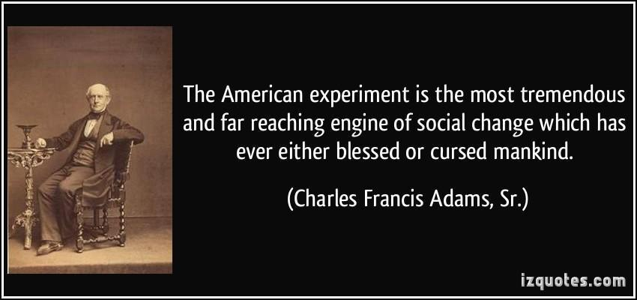

Instructor: Brad Highfield

E-mail: [BHighfield@meca-nyc.org](mailto:BHighfield@meca-nyc.org)

***“Political Science and Economics can be viewed as the study/examination of utopian structures, or the critique of dystopian structures.”***

**Essential Questions:**

How does the American system of government function? What are the roles that society plays in the functioning of the government and economy? What are the issues within our society, within government, within the globalized world, that affect us? How can we act against these issues? How can we solve the problems that surround us—that surround the world? Why are some actions/movements more effective than others? How do we become Agents of Change???

**Expected Learning Outcomes:**

***In this semester, we will:***

* Examine the framework of professional scholarship on the social/political issues existent in our time.
* Analyze the craft of peer review writing and consider techniques that extract information from the text and how the tone and choices made by the author convey a specific view.
* Explore ways in which authors use rhetorical devices and persuasive techniques to empower or dissuade the people, as well alter reality & truth.
* Investigate the people and movements that have created change or confronted oppression.
* Build cooperative group-working skills for collaborative learning and engagement in materials and studying.
* Build political literacy through the examination and discussion of current events using news articles.

**Point Distribution:**

***Routine Class Assignments (25%)***

* Assignments that are assigned and completed during a single class period, whether it be completed as a group or individually. Such assignments can include summative written responses/exit tickets, peer or self assessments/critiques, worksheets, short essays, notes… etc.
* Participation includes speaking in class discussions, asking thoughtful questions, reading aloud slides or materials, taking active roles in group activities (note-taker, leader, or speaker).
* And any other additional assignments throughout the semester.

***First Tasks (10%)***

* First task assignments will be completed in the first 5-10 minutes of class.
* First Tasks cannot be made up if you come late to class or have an Unexcused absence.

***Homework Assignments (10%)***

* Current Events Assignment: Students will read TWO news articles that address key topics in politics, government, and economics. This assignment will require answering questions based on the articles, and a short analysis of author’s assertions/arguments. Specific articles may be provided by the teacher.
* Scholarly Articles Assignment: Students will read scholarly articles (may or may not be assigned by teacher) that address the issue being examined for the week due. Assignment will require answering questions based on the articles, and a short analysis of both authors’ assertions/arguments in comparison and contrast of each other.
* Homework assignments will have due dates that are several days after assigning to provide adequate time to complete.

***Mastery Works (Exams, Essays, and Projects) (30%)***

* All exams, essays, and multi-day projects will be attributed to this section.
* Exams and multi-day projects can be weighted differently on a case-by-case basis.
* Essays can include one or more pages, and may assess research or analytical ability. Essays are always graded with a rubric, which will take into account writing conventions.
* **\*\*\*ALL essays must be typed in Google Docs and be submitted from the “live” document in order to show editing history. No PDFs will be accepted, nor will ‘copy-and-pasted’ essays as well.\*\*\***

***Term Paper and related assignments (25%)***

* Students will research and write an essay analyzing a major topic in current events in the United States or around the world. Researching through scholarly articles, news reports, and books--**emphasis will be on the student using experts’ research/viewpoints to express the student’s argument.**
* Thesis Proposal, Article Summaries, Rough Drafts, Annotated Bibliographies, and the Final Drafts will be graded in this category with varying weights attached.
* **\*\*\*ALL essays must be typed in Google Docs and be submitted from the “live” document in order to show editing history. No PDFs will be accepted, nor will ‘copy-and-pasted’ essays as well.\*\*\***

**Policies:**

**Attendance:** We expect you to attend all class sessions; we expect you to be on time and prepared. In the case of an absence, most assignments are provided via Google Classroom with the due date of 3:00pm that day:

* Unexcused absences/latenesses could result in a points deduction if assignments are not handed in on-time.
* An **EXCUSED** absence is when **student provides documentation** of illness or emergency.
* Some assignments will be completed ONLY in class and will not be available on Google Classroom.

**Late Assignments:** We expect you to complete all assignments on time. However, late assignments will be accepted until the end of marking period.

* Late work submitted less than one week following the due date = score no higher than a 80%.
* Late work submitted later than one week after due date = score no higher than a 65%.
* ***“Missing assignments” will receive a score of 10%.***
* Requests for extensions = considered only when requested **at least 24 hrs before** due date.

*\*\*\*Extensions without point deductions may or may not be granted. If you have a family emergency, please inform me of the nature of the emergency within your comfort.*

**************************************************************************

**Behavior:** Some of the material in the course may evoke personal feelings, emotions, and responses. Sharing our honest thoughts, opinions, and writing requires us all to listen to one another with open minds. We will not tolerate any insults or rude comments. We expect each of you to demonstrate maturity, empathy, and understanding.

***************************************************************************

**Electronics:** ***There are no electronic devices permitted for use in our class sessions without explicit permission***. Your phones must be silent and in your Yondr pouch. No laptops, ipads, or e-readers should be open unless provided explicit permission.

**Academic Integrity:** BMCC Policy on Plagiarism and Academic Integrity Statement **Plagiarism is the presentation of someone else's ideas, words or artistic, scientific, or technical work as one's own** creation. Using the idea or work of another is permissible only when the original author is identified. Paraphrasing and summarizing, as well as direct quotations, require citations to the original source. Plagiarism may be intentional or unintentional. Lack of dishonest intent does not necessarily absolve a student of responsibility for plagiarism. Students who are unsure how and when to provide documentation are advised to consult with their instructors. The library has guides designed to help students to appropriately identify a cited work.

**Students suspected of a violation of academic integrity risk failure of the assignment, notification of parent/guardian. Current academic standing in the course will not be taken into consideration.**

***\*\*Plagiarism and/or cheating on an assignment will result in a ZERO on the assignment for the student who plagiarized, AS WELL AS the student who had helped them. You will not be allowed to make up the assignment.***